You can help……
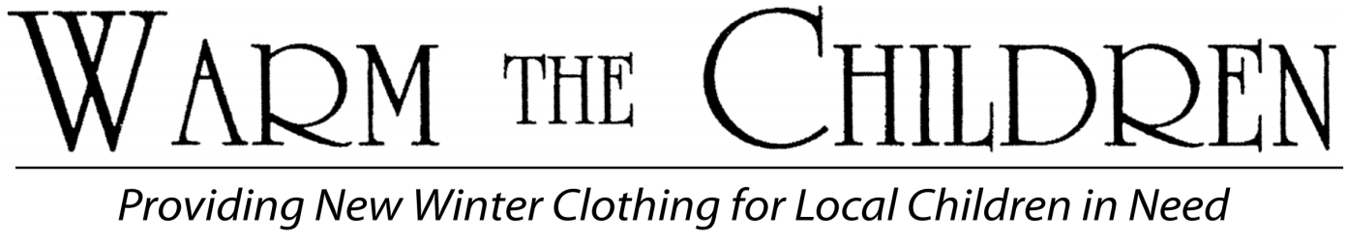
The need is great this year! In Torrington, Winsted and surrounding communities little children will go cold without your help.

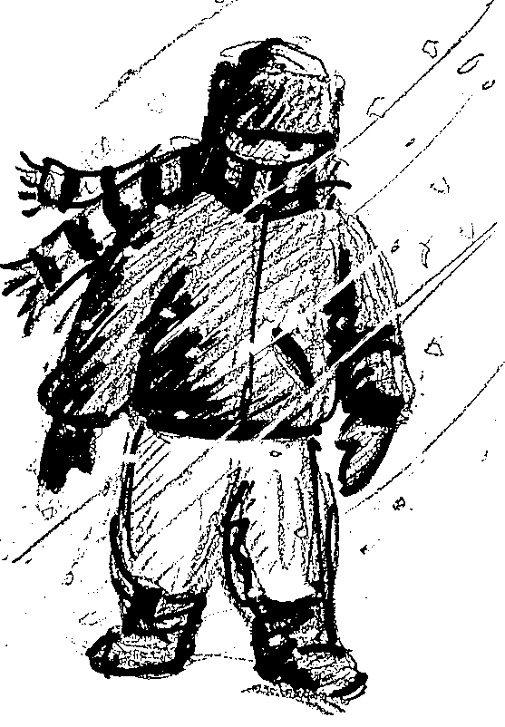
Just what is the Warm the Children program?
Warm The Children is neighbors helping neighbors. The Register Citizen and United Way of Northwest Connecticut are asking readers to donate to the fund, and the proceeds will be used to buy new warm winter clothing and footwear for area children in need. There are no administrative fees; all donated money is used to buy warm winter wear.

How are families with children in need identified?
Children/families in need are identified by the Vogel Family Resource Center, the Salvation Army in Winsted and Torrington, Friendly Hands Food Bank, Winsted Area Child Care, FISH of Northwest Connecticut, Falls Village Day Care, and Canaan Child Care Center. Each provides family contact information to the Warm the Children coordinator.

How will the children’s clothing be purchased?
The Warm the Children coordinator assigns families to a volunteer shopper who meets the families at Walmart and assists in selecting up to $80 ( age 4 and under up to $60) in winter clothing and footwear for each child. Walmart bills Warm the Children for all purchased items.

How can I help?
Your donation of any amount is appreciated. You can donate by mail or on-line. By mail - simply complete the coupon below and mail it with your check to the address on the coupon. On-line – using PayPal go to www.warmthechildren.org, select donate, then select Torrington from drop down menu.
All donations are tax deductible.

Warm the Children is a joint effort of
The Register Citizen &
Enclosed is my donation to Warm the Children

Name __________________________________________________________________________________
Address:__________________________________________________________________
Email: ________________________________________ Donation amount: __________
Special Instructions: _________________________________________________________
______________________________________________________________
___ Do not publish my name in the list of donors
Donations are Tax deductible.
Please make check payable to: Warm the Children
Mail to: Warm the Children
PO Box 1001, Torrington, CT 06790

